Day 3 — Spark Setup and First Application
Project Folder Creation:
A separate folder named Day3-Spark-Setup was created inside the existing daily-project repository. This keeps the Day 3 Spark application organized independently from the previous Scala projects while allowing all daily projects to be maintained in a single GitHub repository.

build.sbt:
The build.sbt file is the build configuration file of the Scala project. It specifies the Scala version, project name, project version and external dependencies. Apache Spark libraries are added as dependencies so that Spark classes such as SparkSession and SparkContext can be used in the application.

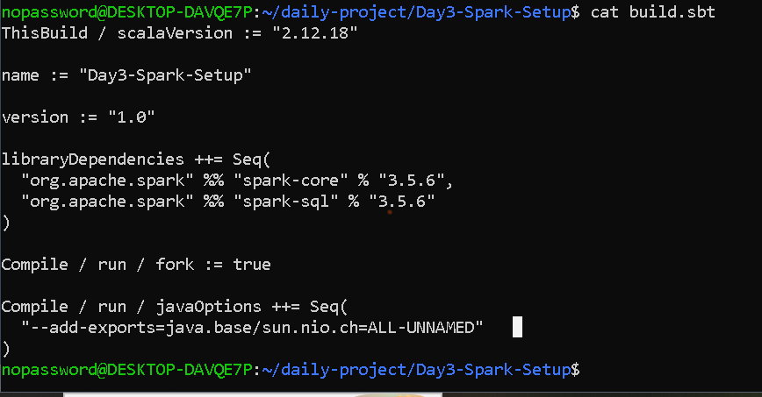

build.properties:
The project/build.properties file specifies the sbt version used by the project. This makes the build environment more consistent because the project records which sbt version should be used.
The sbt documentation describes project/build.properties as the location where the sbt version is tracked.
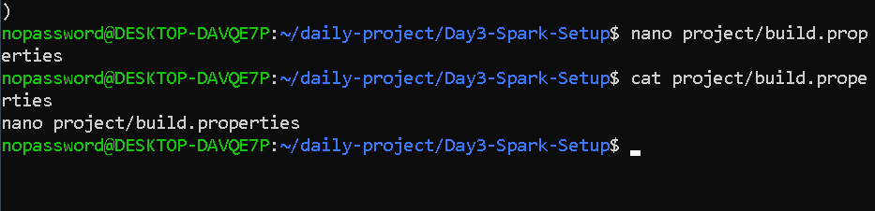

Create the input text file
We need a text file for Spark to read.
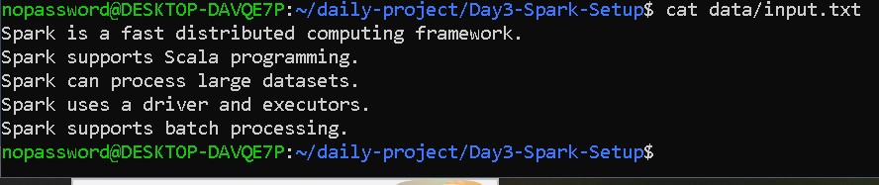

Understand the code
This is important for your viva.

SparkSession
val spark = SparkSession.builder()
SparkSession is the main entry point for Spark applications.
It allows you to work with:
- DataFrames
- SQL
- Spark functionality

.appName()
.appName("Day3 Spark Application")
This gives your Spark application a name.

.master()
.master("local[*]")
This tells Spark to run locally.
* means Spark can use the available cores.
Later we'll change this to:
local[2]
and:
local[4]

10. SparkContext
This line:
val sc = spark.sparkContext
gets the application's SparkContext.

What is SparkContext?
SparkContext is the connection between your Spark application and the Spark execution environment.
It coordinates:
- jobs
- tasks
- executors
- data processing
For your viva:
SparkSession is the modern entry point for Spark applications, while SparkContext provides the lower-level connection to Spark's execution environment.

11. Read the text file
This:
val lines = sc.textFile("data/input.txt")
reads the text file into an RDD.
You can explain:
textFile() reads the input text file and creates an RDD where each line of the file is treated as an element.

12. Display the file
This:
lines.collect().foreach(println)
collects the data to the driver and prints each line.
For a small educational input file this is fine.
Don't use collect() blindly on huge datasets because it brings all data to the driver and can cause memory problems.

13. Count the lines
lines.count()
returns the number of lines in the RDD.
If our file has 5 lines:
Total number of lines: 5

14. Stop Spark
Finally:
spark.stop()
stops the Spark session and releases resources.
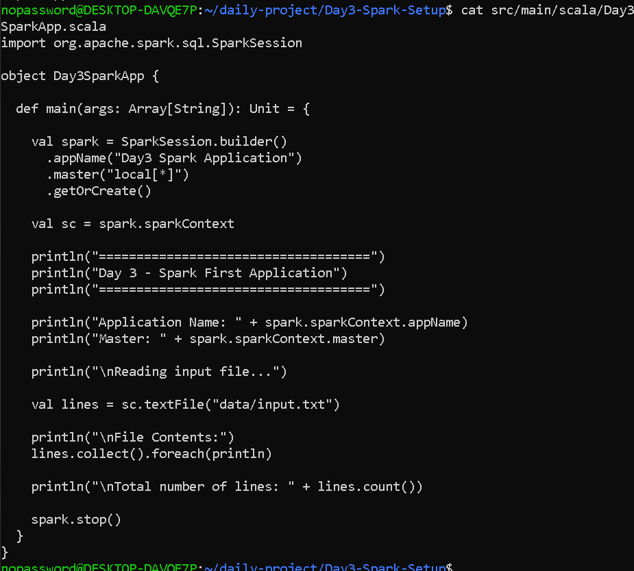

The important part is that your application completed successfully with:
[success] elapsed time: 11 s
and:
SparkContext is stopping with exitCode 0
Your program:
- Started Spark 3.5.6 with Java 17.
- Created the Spark application Day3 Spark Application.
- Started the local Spark executor.
- Read your input.txt.
- Displayed all 5 lines.
- Counted the lines and got 5.
- Shut Spark down normally with exit code 0.

But one thing!
Your output still says:
Master: local[*]
So this is your normal local[*] test, not yet the required local[2] test.
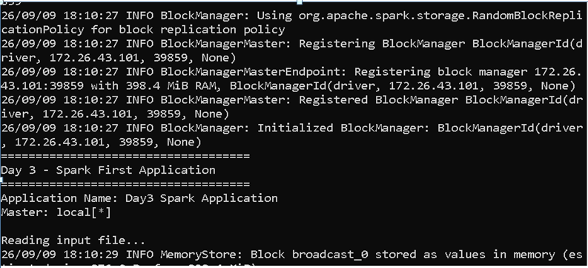
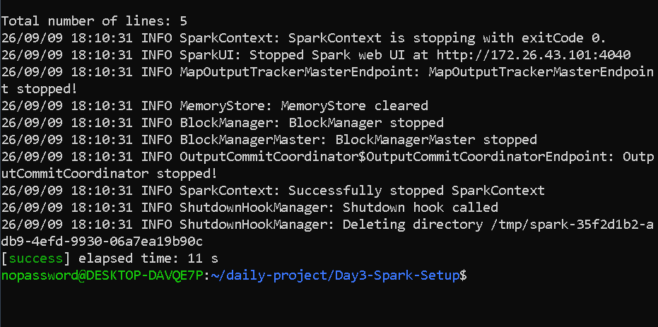

the Spark project was compiled using the sbt compile command. sbt resolved and downloaded the required Scala and Apache Spark dependencies specified in build.sbt. After successful compilation, the application was executed using sbt run. The Spark application successfully created a SparkSession and SparkContext, read the input text file and displayed its contents.

Now we do the actual 2-core and 4-core experiment
Run this for core 2 --
sed -i 's/local\[\*\]/local[2]/' src/main/scala/Day3SparkApp.scala
grep master src/main/scala/Day3SparkApp.scala
sbt run
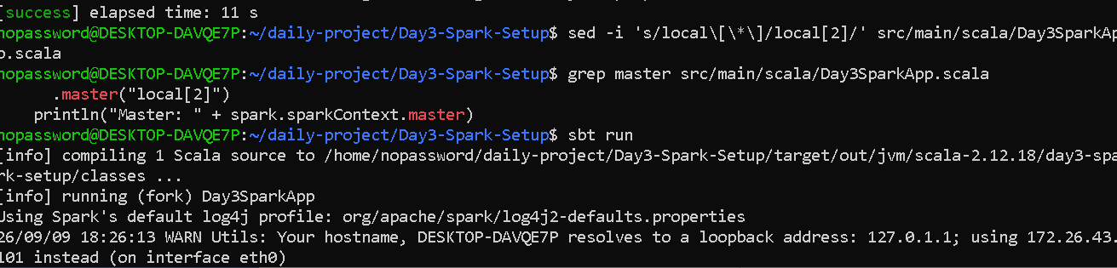
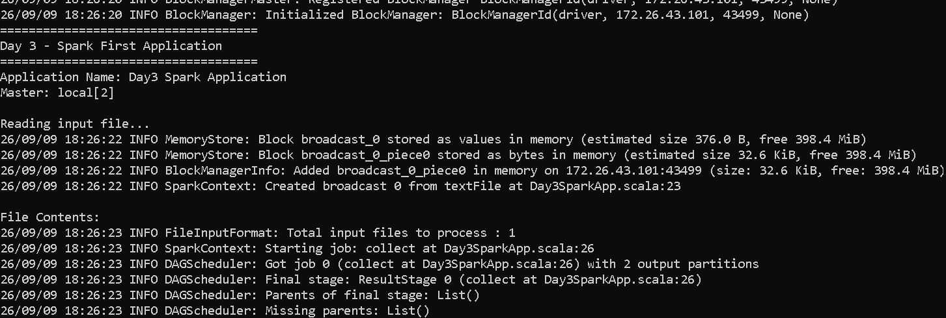
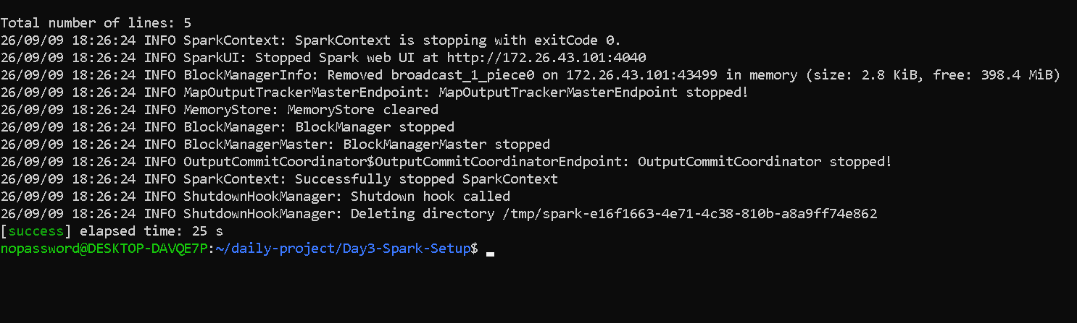

Test with 4 cores
After the 2-core test finishes:
sed -i 's/local\[\2\]/local[4]/' src/main/scala/Day3SparkApp.scala
grep master src/main/scala/Day3SparkApp.scala
sbt run
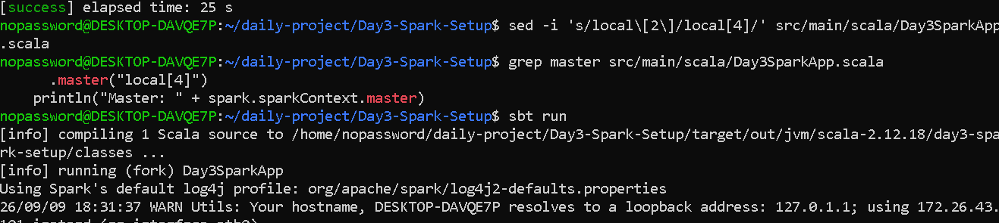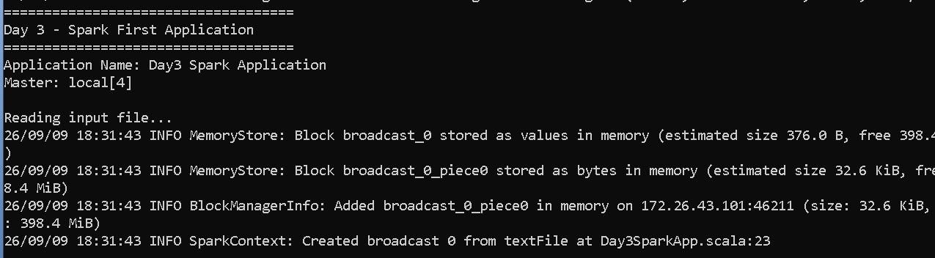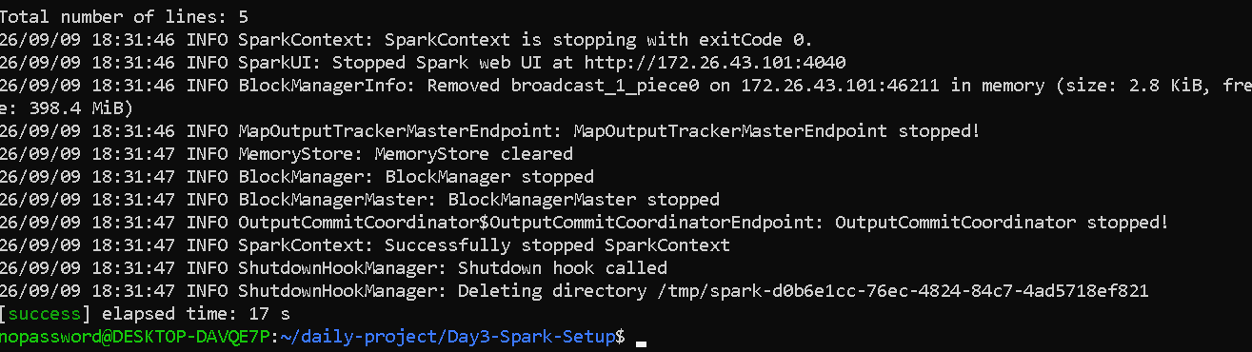

For reference---

Day 3 — Spark Setup and First Application

1. Introduction
Apache Spark is a distributed computing framework used to process large amounts of data efficiently. Spark supports multiple programming languages, including Scala, Python, Java, and R.
In this task, a basic Spark application was developed using Scala and sbt. The application creates a SparkSession and SparkContext, reads data from a text file, displays the contents, counts the number of lines, and terminates the Spark application.
The application is also designed to run in local mode using different numbers of CPU cores.

2. Objectives
The main objectives of this task are:
- Create a Scala Spark project using sbt.
- Configure Apache Spark dependencies.
- Create a SparkSession.
- Create or access a SparkContext.
- Read a text file using Spark.
- Display the contents of the file.
- Understand Driver, Executor, and Cluster Manager.
- Run the application in local mode using 2 cores.
- Run the application in local mode using 4 cores.

3. Tools and Technologies
Technology | Version / Purpose
Java | 17
Scala | 2.12.18
Apache Spark | 3.5.6
sbt | 1.10.1
Operating System | Ubuntu 24.04 on WSL2

4. Project Configuration
The project was created using sbt.
The build.sbt file contains the Scala version and Spark dependencies.
ThisBuild / scalaVersion := "2.12.18"

name := "Day3-Spark-Setup"

version := "1.0"

libraryDependencies ++= Seq(
"org.apache.spark" %% "spark-core" % "3.5.6",
"org.apache.spark" %% "spark-sql" % "3.5.6"
)

Compile / run / fork := true

Compile / run / javaOptions ++= Seq(
"--add-exports=java.base/sun.nio.ch=ALL-UNNAMED"
)
The Spark Core dependency provides the basic Spark functionality, while Spark SQL provides Spark's SQL and DataFrame-related functionality.

5. Role of sbt
sbt stands for Scala Build Tool.
It is used to:
- Compile Scala source code.
- Manage project dependencies.
- Run the application.
- Package Scala applications.
- Manage the project build configuration.
The following command was used to compile the application:
sbt compile
The application was executed using:
sbt run

6. SparkSession
SparkSession is the main entry point for working with Spark in modern Spark applications.
The application creates a SparkSession using:
val spark = SparkSession.builder()
.appName("Day3 Spark Application")
.master("local[*]")
.getOrCreate()
The appName() method specifies the application name.
The master() method specifies where Spark should run.
For example:
local[*]
means that Spark runs locally using all available logical CPU cores.

7. SparkContext
SparkContext represents the connection between the application and the Spark execution environment.
It can be accessed from SparkSession:
val sc = spark.sparkContext
SparkContext is used in this project to create an RDD from the input file:
val lines = sc.textFile("data/input.txt")

8. Reading the Input File
The input file is located at:
data/input.txt
It contains five lines of text.
The file is read using:
val lines = sc.textFile("data/input.txt")
textFile() creates an RDD where each line of the text file becomes an element of the RDD.
The contents are displayed using:
lines.collect().foreach(println)
The number of lines is calculated using:
lines.count()
The output confirms:
Total number of lines: 5
collect() is suitable for this small demonstration, but it should be used carefully with large datasets because it brings all the data to the Driver.

9. Spark Architecture
Spark applications generally consist of a Driver, Executors, and a Cluster Manager.

9.1 Driver
The Driver is the main coordinating process.
Its responsibilities include:
- Starting the Spark application.
- Creating the SparkContext.
- Creating jobs from application operations.
- Dividing work into stages and tasks.
- Coordinating task execution.
The Driver can be considered the "brain" of the Spark application.

9.2 Executor
Executors are worker processes that execute tasks assigned by the Driver.
They:
- Perform computations.
- Process partitions of data.
- Store intermediate data when required.
- Return results to the Driver.
A simple way to remember this is:
Driver coordinates, Executor computes.

9.3 Cluster Manager
The Cluster Manager is responsible for allocating resources for Spark applications.
Examples include:
- Spark Standalone
- Hadoop YARN
- Kubernetes
In this project, Spark is executed in local mode, so an external cluster manager is not required.

10. Local Mode
Local mode allows Spark to run on a single machine.
The master setting determines how many local threads are used.

local[2]
.master("local[2]")
This runs the application locally using two worker threads.

local[4]
.master("local[4]")
This runs the application locally using four worker threads.

local[*]
.master("local[*]")
This uses all available logical CPU cores.
Local mode is useful for learning, development, testing, and debugging before deploying an application to a real cluster.

11. Experimental Procedure

Step 1 — Compile
cd ~/daily-project/Day3-Spark-Setup
sbt compile
The project compiled successfully.

Step 2 — Run in Local Mode
The application was initially configured with:
.master("local[*]")
It successfully read and displayed all five lines from the input file.

Step 3 — Run Using 2 Cores
The master configuration was changed to:
.master("local[2]")
The application was then executed using:
sbt run

Step 4 — Run Using 4 Cores
The master configuration was changed to:
.master("local[4]")
The application was executed again:
sbt run

12. Results
The application successfully reads the input file and displays its contents.
Test | Spark Master | Input Lines | Result
Initial Run | local[*] | 5 | Successful
Test 1 | local[2] | 5 | Successful
Test 2 | local[4] | 5 | Successful
The important difference between the tests is the number of local worker threads available for Spark execution.

13. Important Spark Concepts

RDD
RDD stands for Resilient Distributed Dataset.
It is a distributed collection of data that Spark can process in parallel.

Transformation
A transformation creates a new dataset from an existing dataset.
Examples:
map()
filter()
flatMap()
Transformations are evaluated lazily.

Action
An action triggers computation and produces a result.
Examples:
count()
collect()
In this project, both collect() and count() trigger Spark computation.

Lazy Evaluation
Spark does not immediately execute transformations when they are defined. It builds an execution plan and executes the required operations when an action is called.

14. Key Observations
The application demonstrated that:
- Scala can be used to develop Spark applications.
- sbt manages the Scala project and Spark dependencies.
- SparkSession is the main entry point to Spark.
- SparkContext provides access to the Spark execution environment.
- textFile() can be used to read text data.
- The input file contained five lines.
- The application successfully executed in local mode.
- The number of local worker threads can be configured using local[2] and local[4].
- In local mode, the Driver and Executor run on the same machine.

15. Conclusion
The Day 3 task successfully demonstrated the setup and execution of a basic Apache Spark application using Scala and sbt.
The application created a SparkSession and SparkContext, read a text file into an RDD, displayed the file contents, and counted the number of lines.
The experiment also provided an understanding of Spark's basic architecture, including the Driver, Executor, and Cluster Manager. Running the application with different local configurations such as local[2] and local[4] demonstrated how Spark can use different numbers of local processing threads.
This task provides the foundation for developing more advanced Spark applications involving transformations, actions, DataFrames, SQL, and distributed data processing.

